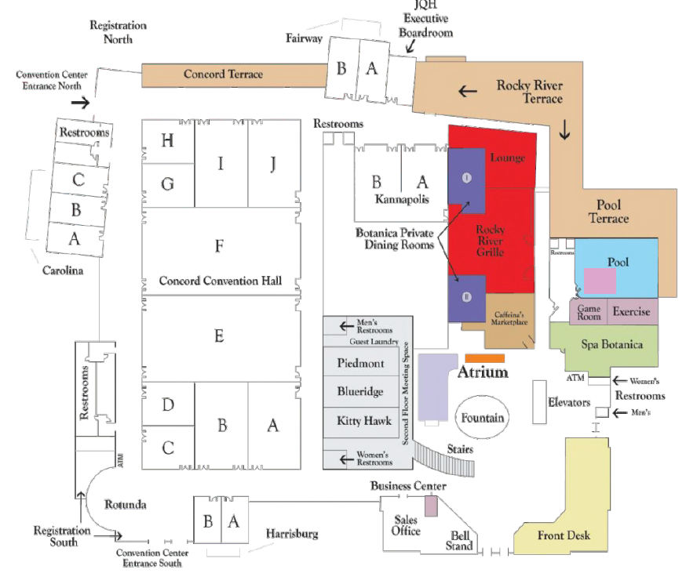
Missionary
Women
Brown Singers
Children
Prayer
Admin
Seniors
Youth Rooms
Convocation Services
Vendors
Security
Health
Hospitality

